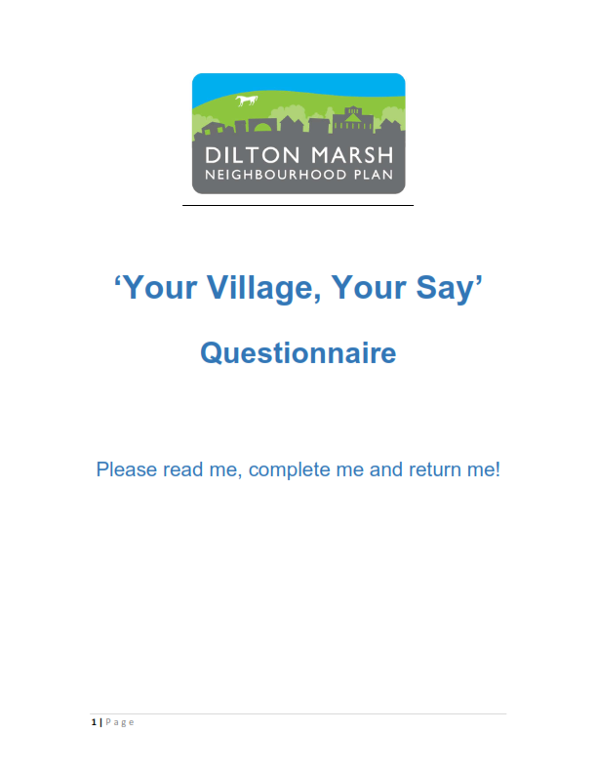
Dilton Marsh Neighbourhood Plan
Pre-submission Regulation 14
Consultation
31st January – 13th March 2024
Dilton Marsh Parish Council and its residents have been working together to create a Neighbourhood Development Plan (NDP) to help shape the growth and development of the local area. The draft Plan has now been written and is open for comments from residents, businesses and any others with an interest in the area, via a public consultation.
The draft Plan and all supporting documents are available on the Parish Council website:
https://bit.ly/3vLnQIh or QR code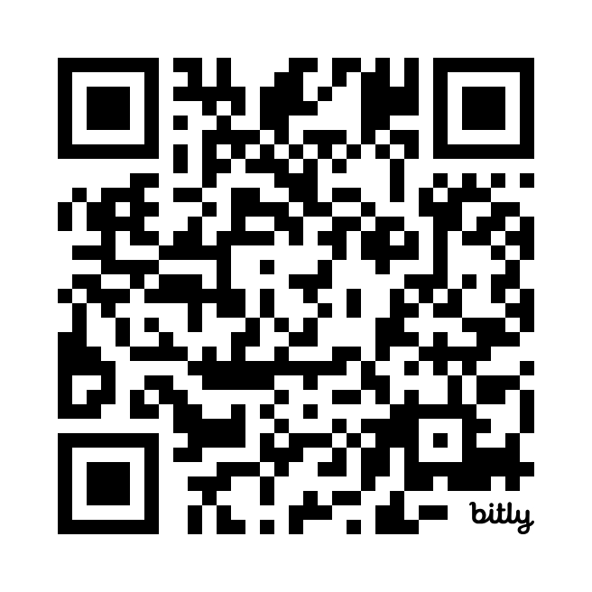
Please use this form to provide your feedback.
All comments should be returned by 5pm on Wednesday 13th March 2024
By email to: clerk@office.diltonmarshparishcouncil.gov.uk
Alternatively, you can return paper copies of the form to the drop-off box in the Weavers pub or Social Club.
Thank you for taking part in our consultation.
What happens next?
The comments will be reviewed by the NDP Steering Group and the Plan updated where necessary. The Parish Council will then agree to submit the final Plan to Wiltshire Council. Wiltshire Council will conduct the final period of public consultation before appointing an independent Planning Inspector to examine the plan against a set of basic conditions. Once this process has been concluded the final stage is a village-wide referendum on the NDP.
If more than 50% of the voters are in favour of the NDP, the local authority must bring it into force This means that it will form part of the statutory Development Plan for Wiltshire, so any decisions about whether or not to grant planning permission in the Dilton Marsh Neighbourhood Area in the future must be made in accordance with your neighbourhood plan, unless material considerations indicate otherwise.
PLEASE NOTE: Your personal details will not be published as part of the consultation response, but anonymous comments will not be actioned so please provide personal details to accompany your comments. Communication regarding progress of the Plan and amendments to be made will be publicised. No individual responses will be given. Dilton Marsh Parish Council have a duty to protect personal information and will process personal data in accordance with Data Protection legislation. The personal data you provide on this form will only be used for the purpose of the Dilton Marsh Neighbourhood Plan. The data will be stored on computer and/or manual files. You have a right to a copy of your information held by any organisation, with some exemptions. This data will be passed on to Wiltshire Council for the Regulation 16 Consultation. To gain access to your personal data held by Dilton Marsh Parish Council please contact the Parish Clerk clerk@office.diltonmarshparishcouncil.gov.uk
Dilton Marsh NDP Regulation 14 comments form
Please specify the Plan page, section, paragraph or policy which you are commenting on. Please use a separate row for each new comment.
Personal Details
Name | Click or tap here to enter text.
Organisation (if applicable) | Click or tap here to enter text.
Postal Address | Click or tap here to enter text.
Email Address | Click or tap here to enter text.

Representations
Plan page and paragraph, or policy number | Comment
Click or tap here to enter text. | Click or tap here to enter text.
Click or tap here to enter text. | Click or tap here to enter text.
Click or tap here to enter text. | Click or tap here to enter text.
Click or tap here to enter text. | Click or tap here to enter text.
Please continue on separate sheet as necessary.

